**ST. VINCENT DE PAUL R.C. CHURCH**

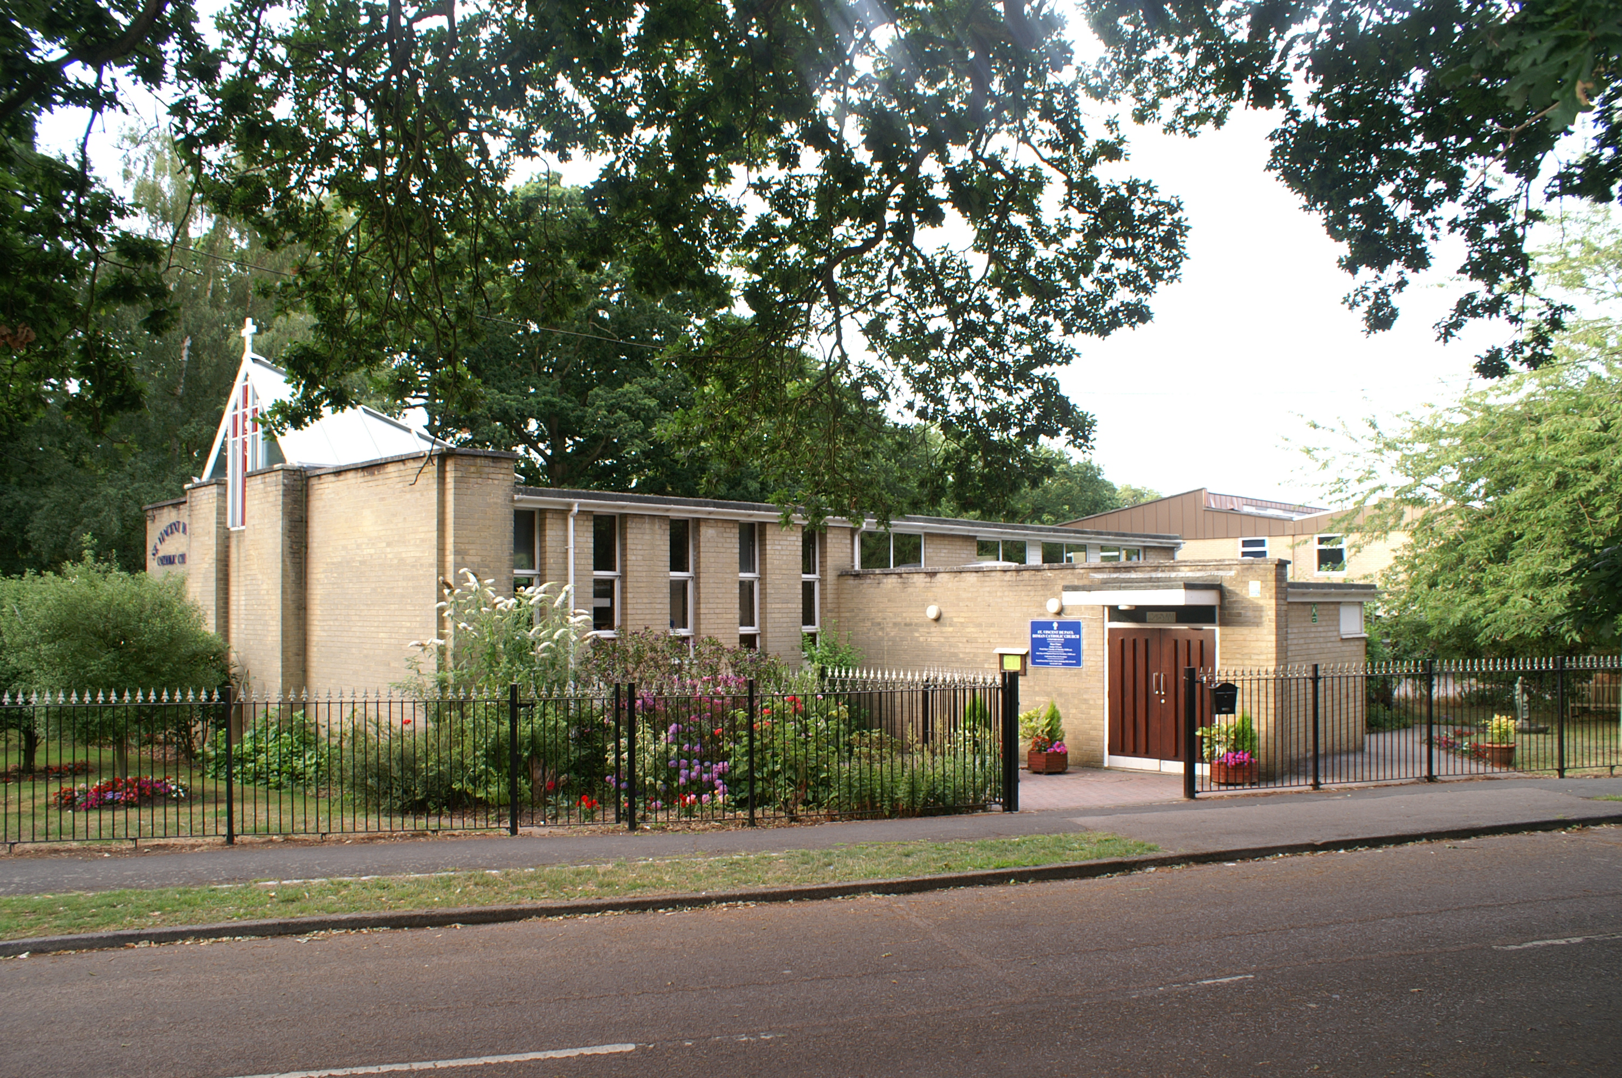

Aldermoor Close, off Coxford Road, Lordswood, Southampton, Hampshire. SO16 5ST

**Parish Priest:** Father Tomy Chirackalmanavalan

**Contact details:** email: fathertomy@portsmouthdiocese.org.ukMobile: 07480730503

**Retired Priest:** Father Michael Cronin Mobile: 07400262398 (1pm to 5pm)

**Office Administrator**: Renee Sharp email: svpoffice@portsmouthdiocese.org.uk

**Newsletter editor**: Malcolm Forster email:malcolmandrita@btinternet.com

21 Bassett Crescent West, Bassett, Southampton SO16 7EB

Tel: 023 80790942Mobile: 07774 400115

**Third Sunday of Lent Sunday 12th March 2023**

#### Exodus 17: 3-7 Romans 5: 1-2, 5-8 John 4: 5-42

Today’s readings are cantered on Baptism and new life. Living water represents God’s Holy Spirit Who comes to us in Baptism, penetrating every aspect of our lives and quenching our spiritual thirst. The Holy Spirit of God, the Word of God, and the Sacraments of God in the Church are the primary sources of the living water of Divine Grace. We are assembled here in the Church to drink this water of eternal life and salvation. Washed in it at Baptism, renewed by its abundance at each Eucharist, invited to it in every proclamation of the Word, and daily empowered by the anointing of the Holy Spirit, we are challenged by today’s Gospel to remain thirsty for the living water, which only God can give. The first reading describes how God provided water to the ungrateful complainers of Israel, thus placing Jesus’ promise within the context of the Exodus account of water coming from the rock at Horeb. In the second reading, Saint Paul asserts that, as the Saviour of mankind, Jesus poured the living water of the gift of the Holy Spirit into our hearts. In the Gospel, an unclean, ostracized Samaritan woman is given an opportunity to receive the living water. Jesus awakened in the woman at the well a thirst for the wholeness and integrity which she had lost, a thirst which he had come to satisfy. This Gospel passage also gives us Jesus’ revelation about himself as the Source of Living Water and teaches us that we need the grace of Jesus Christ for eternal life because he is that life-giving water.

**Yours, Fr. Tomy**

|  |  |
| --- | --- |
| **Mass times Feast Days** | |
| **6pm: Confessions**  **6.30pm Vigil Mass** | **Saturday 11thSt Maximilian of Tebessa** Born about 274 in Tebessa, part of present day Algeria. His father, a Christian named Fabius Victor, was formally a soldier in the Roman army. The area of North Africa had been controlled by Rome for four centuries. In 295, a Roman proconsul sailed to North Africa to recruit soldiers for the Third Augustine Legion stationed in the area. Most were volunteers , but there was an obligation of service for sons of veterans. Maximilian was recruited for the Roman army when he was 21 years old and a Christian. He was tall and physically very strong and ideal for the army but was a “conscience objector” and refused to fight or to offer sacrifices to pagan gods and would not swear allegiance to the Roman Emperor saying, “I will not be a soldier of this Roman army. I am a soldier of Christ and will only fight for Him. He was executed by being beheaded by the sword. |
| **9.30 am** | **Sunday 12thMarch Third Sunday of Lent Nikki Okonicwd** |
| **First Communion Training from 16:45 t0 17:45**  **6.30 pm** | **Monday 13th Blessed Agnellus of Pisa** Born in 1195 in Pisa, Italy. Franciscan recruited by Francis of Assisi. Founded Friary at Paris University. Present at the first *Chapter of Mats* in 1218 in Italy with Francis and 5,000 priests and friars. Sent with 7 others by Francis to England to establish the first Franciscan monasteries. First friars in Canterbury, London and Oxford based on absolute poverty. Founded theology school at Oxford University that had famous scholars. Friend of King Henry III. Influential in affairs of State as humble, prudent advisor and peace negotiator. Averted English civil war. There were 43 Franciscan friaries in England at his death in 1236 |
| **10 am**  **Thanksgiving Mass for 6th birthday of Christal Thomas** | **Tuesday 14th St Leobinus of Chartres** Born in France about 480 to peasant farmers. Worked in the fields but was full of intellectual curiosity. Keen to learn he went to the local monastery. He carried out menial tasks all day and studied at night. Gained considerable religious knowledge. Spent time as a hermit with St Avitus. Joined monastery at Lyons Abbey. Five years later the monastery was raided. Leobinus was tortured to disclose where the monastery kept its treasurers. Refused to tell them and left for dead. Recovered and rejoined St Avitus at La Perche. Appointed Abbot of Brou and ordained a priest although he preferred the life of a monk. Then made Bishop of Chartres. Carried out many reforms and was involved in 5th Council of Orleans and 2nd Council of Paris. Died 14th March 558. |
| **SVP Social 1- 3pm**  **6.30 pm**  **Mass for personal intention** | **Wednesday 15th St Louise de Marillac** Born France in 1591 out of wedlock. Lived among French aristocracy and educated in royal monastery. Wanted to be a nun. Rejected due to poor health. Uncle arranged a marriage. Had a son. Husband lost his job in the royal court after civil unrest. Suffered chronic illness. Cared for by Louise. Vincent de Paul gave her a new challenge in Paris to help the poor. She founded *Daughters of Charity of St Vincent de Paul* that worked in the community |
| **10 am**  **Thanksgiving Mass for birthday of Albñt Jobñn** | **Thursday 16th St Clement Mary Hofbauer** Born Czech Republic 1751 son of a farmer and butcher who died when he was 6. Aged 15, apprentice baker in Znojmo. Baker at Austrian Priory. Hermit. Baker in Vienna. Hermit at a shrine in Rome. Trained as a priest at Vienna University. Joined the Redemptorists in Rome. Ordained a priest. Established Redemptorists in Warsaw, Poland. Refuge for homeless children in active parish. Expelled from Poland by Napoleon. Chaplain to hospital to care for the wounded in Vienna. Founded a College. Intellectual discussions with students. Brought rich, influential and artistic people into the Church. Stopped a national Church in Germany.. Died 1820 |
| **6pm: Stations of the Cross**  **9pm: 8 hours of adoration** | **Friday 17th St Patrick** Born in 387 in Scotland to Roman parents. At age 15 was captured by Irish raiders and sold as a slave in Ireland. Was 6 years a shepherd to a cruel chieftain. Then escaped back to Scotland. Trained for the priesthood in Gaul, present day France. Sent as part of a mission to Britain where he was ordained a priest. Then led missionaries to Ireland. Opposed pagan Druids with great success. Evangelised Ireland with the help of St Brigid. Built many churches and monasteries. |
| **6pm: Confessions**  **6.30pm Vigil Mass**  **John and Pat Moon and all members of Moon family** | **Saturday 18th March St Cyril of Jerusalem** Born in about 315 near Jerusalem. Deacon, priest and then Bishop of Jerusalem. Opposed heresy of *Arianism* which the Bishop Acacius of Caesarea supported. Jerusalem in the Holy Land was considered more important than Caesarea. Caused conflict between Cyril and Acacius. Acacius accused Cyril of selling Church property, which he did to feed the poor. Bishop Cyril ignored him. Synod deposed Bishop Cyril who went into exile. Reinstated and then deposed again twice more. Took part in the Second Ecumenical Council in 381. Helped to rewrite the Nicene Creed to exclude the heretic Arian beliefs. He died exhausted in 386 aged 71. |
| **9.30 am** | **Sunday 19th March Fourth Sunday of Lent Nora and Michael Hunter RIP** |
| **PLEASE PRINT IN BLOCK CAPITALS WHEN RECORDING NAMES FOR MASS INTENTION** | |

|  |  |  |  |  |  |
| --- | --- | --- | --- | --- | --- |
| **Your prayers are needed for the following people** | | | | | |
| Diana Stimson | Sue Chandler | Hazel Sale | Joe Heatley | Kay Duggan |  |

**NOTICES AND ANNOUNCEMENTS**

**Special Collection last weekend after CAFOD Family Fast Day for Lent**

A total of £280.90 was collected. Also £95 was sent in envelopes with gift aid forms enclosed so that CAFOD could claim the gift aid from the donations by CAFOD. At the moment it is diocesan policy that gift aid from special collection parish envelopes is retained in the parish and not sent to the charity.

**SVP Social on a Wednesday 15thMarch – 1 to 3 pm**

Another opportunity to meet for refreshments and a chat. Come along and bring your friends. No need to stay for the whole time, a few minutes of two hours. Look forward to welcoming you. Renee and Pat.

**Friday 17th March: 8 hours of adoration followed by Mass from 9 pm to 5 am**

We are having 8 hours of adoration starting at 9 pm and ending with Mass at about 4 am.

**Diocesan Fund Raising Campaign:**

Every Thursday after the 10.30am morning Mass until May, one of the team members of the campaign from the diocese will be available for discussion with parishioners. The fund raising programme is for the support of clergy and the parish. The target given to our parish is £30,000 over five years. From this amount, twenty thousand will be going to clergy welfare and ten thousand will be given back to the parish.

If any parishioner cannot attend the Thursday event, Fr Tomy is prepared to talk to anyone after any of the parish Masses and answer questions concerning the campaign.

|  |  |
| --- | --- |
| **Parish collection for last weekend 4th and 5th March** | **SPECIAL COLLECTION**  **Racial Justice Sunday** |

|  |  |  |  |  |  |  |  |  |  |  |  |  |  |  |  |  |  |  |  |
| --- | --- | --- | --- | --- | --- | --- | --- | --- | --- | --- | --- | --- | --- | --- | --- | --- | --- | --- | --- |
| **Envelopes** | | **Gift Aid** | | **Loose plate** | | **Direct debits, standing orders** | | **Gift Aid** | | **Total of Offertory Collection** | | **Other money** | | **Envelopes** | | **Loose plate** | | **TOTAL of all money** | |
| £99.00 | | £24.75 | | £195.07 | | £300.23 | | £68.13 | | £687.18 | | **---** | | £166.70 | | **£114.20** | | **£968.08** | |

**Gift Aid envelopes are now available in the porch for donations for the next financial year.**

**PLEASE NOTE** – due to the amount of space and print that Diocesan job vacancies take up, I have copied current vacancies and made a space for them on the notice board to your right as you enter the Church. Alternatively you can get details from recruitment@portsmouthdiocese.org.uk

**Stella Marist Seafarers Easter Egg Appeal from ship visitors Charles Stuart and Gregory Hogan.**

As last year, Easter eggs are being collected to give to seafarers who will be confined to their ships over the Easter period. Parishioners were very generous last year so hopefully we can do the same again. Also woollen hats were knitted using the pattern given to us by Stella Marist, or Apostleship of the Sea.